venv\Scripts\activate
pip install -r requirements.txt
uvicorn main:app --reload --port 8000
cd C:\rag-engine\frontend
npm install
npm run dev
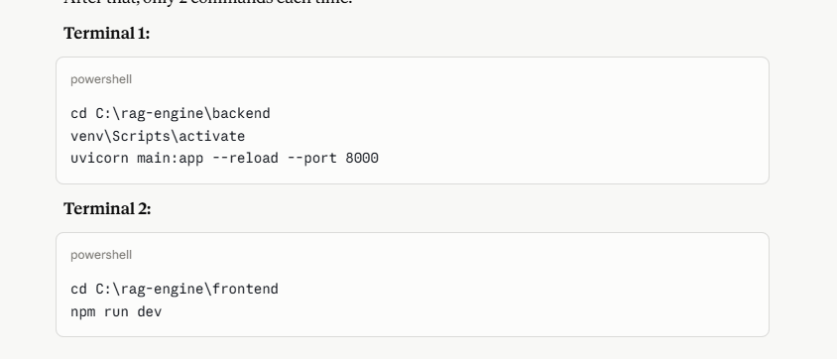

pip install --only-binary=:all: fastapi uvicorn[standard] python-multipart httpx pypdf python-docx python-dotenv pydantic
